

H

ACKNOWLEDGEMENT 5

Aim 6

Introduction 7

Overview 8

Scope of the project 9

Software and Libraries 10

Program design 12

database structure 13

code 14

Screen Shots 15

Future Enhacements 16

references 17

# ACKNOWLEDGEMENT

Behind every success endeavor is the guiding hand of the almighty. To that ever compassionate lord **BHAGAWAN SRI SATHYA SAI BABA**, I offer my deep sense of gratitude. I also take this opportunity to thank him for providing us with dedicated teachers.

I would like to take this opportunity to express my gratitude to the principal sir, **SHRI SIVARAMAKRISHNAIAH** for giving me this wonderful opportunity.

I also take this opportunity to express my heartfelt gratitude to my Informatics teacher, **SHRI SAI PAVAN** for motivating and guiding me all throughout and enabling me make this project a success.

Lastly, I thank my **PARENTS** for the constant support and inspiration and my **CLASSMATES** for their unending support and encouragement.

# Aim

To create a robust and dynamic tours and travels application that ensures a prompt and friendly front-end with well - structured database that makes the user have a pleasant experience.

# Introduction

Digitalisation refers to the integration of digital technologies into all areas of business and society, fundamentally transforming how we operate and deliver value. This process involves converting information into digital formats, enabling more efficient data management and accessibility. Digitalisation enhances productivity, streamlines operations, and fosters innovation by leveraging technologies such as cloud computing, artificial intelligence, and the Internet of Things (IoT). It also improves customer experiences by providing more personalized and responsive services.

Tours and travels software is designed to streamline and enhance the operations of travel agencies, tour operators, and other travel-related businesses. These software solutions offer a range of features, including online booking systems, itinerary planning. This helps the customers to have an enhanced experience by easily being able to do what they want as this software will make the users better plan their travels and get to know the world better.

# Overview

In the present times of incorporating technology in every aspect of our life this project helps in mordenising the way in which you plan your travels by enhancing the customer experience and providing a comprehensive, user-friendly platform for planning and booking trips. With features that prioritize customization, convenience, and support, it empowers travelers to create memorable experiences with ease. It is designed to streamline and enhance the travel booking experience. It is also integrated with third part services.

# Scope of the project

Traveling is a transformative experience that opens our eyes to the beauty and diversity of the world. It allows us to step outside our comfort zones, break away from our routines and immerse ourselves in different cultures, and create lasting memories. This exposure not only broadens our horizons but also cultivates empathy and appreciation for diversity. This software with the help of an user friendly interface boasting a comprehensive catalog with detailed descriptions

# Software and Libraries

* **Pycharm 2022.2.2**

PyCharm is an integrated development environment used for programming in Python. It provides code analysis, a graphical debugger, an integrated unit tester, integration with version control systems, and supports web development with Django. PyCharm is developed by the Czech company JetBrains.

* **Python 3.9**

Python is an interpreted, high level and general programming language. Its design philosophy emphasizes code readability with its use of significant indentation. Its language constructs as well as its object-oriented approach aim to help programmers write clear, logical code for small and large scale projects.

* **PyQt5**

PyQt is a Python binding for Qt, which is a set of C++ libraries and development tools providing platformindependent abstractions for graphical user interfaces (GUIs.

* **MySQL**

The MySQL Database Software is a client/server system that consists of a multithreaded SQL server that supports different back ends, several different client programs and libraries, administrative tools, and a wide range of application programming interfaces (APIs).

* **MySQL connector**

MySQL Connectors provide connectivity to the MySQL server for client

programs. APIs provide low-level access to MySQL resources using either the classic MySQL protocol or X Protocol.

# Program design

* **Login**

This tab enables the user or the administrator to login to access the features of the module.

* **Main window**

This window is used to proceed to the home page of the application.

* **Home Page**

The homepage of the application features a sleek, user-friendly

interface that prioritizes simplicity and accessibility. A

navigation bar enables users to quickly access different

sections. A dynamic carousel showcases key features

with vibrant images and concise text. Key actions are highlighted

in buttons, making it easy to get started.

* **Tours window**

It features an organised layout showcasing a vast library of tours, each accompanied by vibrant images, a brief description, price details and users can filter based on region.

# database structure

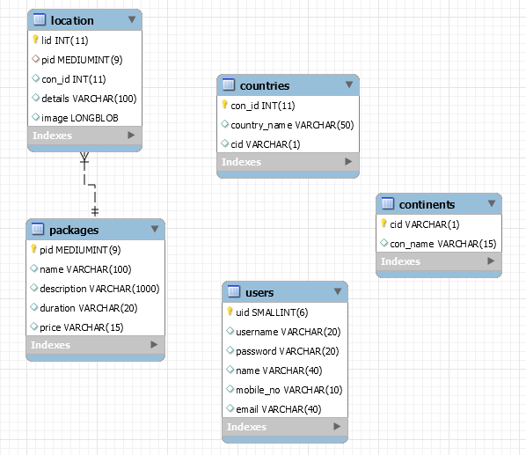

# code

# Screen Shots

# Future Enhacements

# references